Name: Hafiz M. Muneeb Akbar
Roll No: SU92-BSAIM-F24-048
Subject: Programming for Artificial Intelligence (LAB)

Lab Task 8
Skycast — Weather App
Complete Project Documentation

1. Introduction
Skycast is a weather web application built with Python and Flask. The user types a city name and the app fetches and displays live weather data for that city. It uses the free wttr.in API so no API key is needed.
The project has two main files: app.py which handles all the backend logic, and index.html which is the frontend page the user sees.

2. Features
- Search weather for any city in the world
- Shows temperature in both Celsius and Fahrenheit
- Displays humidity, wind speed, visibility, pressure, and UV index
- Emoji icon changes based on the current weather condition
- Shows an error message if the city is not found
- Clean dark-themed responsive UI

3. Dependencies
The project needs two Python libraries listed in requirements.txt:
- flask — the web framework that runs the server and handles routing
- requests — used to call the wttr.in weather API
To install them, run: pip install flask requests

4. Backend (app.py)
The app.py file is the backend of the application. It contains all the logic for fetching weather data, processing it, and responding to requests from the browser.

get_weather(city)
This function takes a city name and fetches live weather data from the wttr.in API.
- Builds the request URL: https://wttr.in/{city}?format=j1
- Sends a GET request with a 5-second timeout
- Reads the JSON response and extracts all the weather fields
- Returns a dictionary with city, country, temperature, humidity, wind, visibility, pressure, UV index, and description
- If anything fails, it returns a dictionary with an error key

get_weather_icon(description)
This function takes the weather description and returns a matching emoji.
- Converts the description to lowercase and checks for keywords
- sunny / clear returns ☀️, partly cloudy returns ⛅, cloudy returns ☁️
- rain / drizzle returns 🌧️, thunder / storm returns ⛈️, snow returns ❄️
- fog / mist returns 🌫️, wind returns 💨, default returns 🌤️

index()
This is the main route function mapped to the / URL. It handles both GET and POST requests.
- On GET: loads the page with an empty search form
- On POST: reads the city name from the submitted form
- Calls get_weather() to get the weather data
- Calls get_weather_icon() to pick the right emoji
- Passes everything to index.html using render_template()

5. Frontend (index.html)
The index.html file is the frontend of the application. It is a single HTML page styled with CSS. Flask uses Jinja2 to fill in the weather data before sending the page to the browser.

Jinja2 Template
Jinja2 is Flask's built-in templating engine. It lets Python variables be used directly inside the HTML file.
- {{ city_input }} — fills the search box with the last searched city
- {% if weather %} — only shows the result section if data exists
- {% if weather.error %} — shows the error box if the API call failed
- {{ weather.temp_c }}, {{ weather.humidity }}, etc. — displays each weather value
- {{ icon }} — shows the emoji selected by get_weather_icon()

Page Sections
- Header — shows the Skycast logo at the top
- Search bar — a form where the user types a city and clicks Search
- Error box — shown in red if the city was not found
- Weather card — the main result section with all the weather info
- Stats grid — shows humidity, wind speed, visibility, pressure, and UV index
- Footer — credits wttr.in as the data source

CSS Styling
- Dark navy background with a star field effect using CSS gradients
- Glassmorphism card with backdrop-filter blur
- Smooth fade-in animations using @keyframes
- Responsive layout using flexbox
- Google Fonts: Syne for headings, DM Sans for body text

6. How to Run
- Install dependencies: pip install flask requests
- Place index.html inside a folder called templates/
- Run the app: python app.py
- Open your browser and go to: http://127.0.0.1:5000/

7. How It Works
- User types a city name and clicks Search
- The form sends a POST request to Flask with the city name
- get_weather() calls the wttr.in API and returns the weather data
- get_weather_icon() picks the right emoji from the description
- Flask renders index.html with all the data filled in
- The browser displays the weather card to the user

8. Error Handling
The get_weather() function uses a try/except block to catch any errors such as a wrong city name, no internet connection, or an API failure. It returns the error as a message. The HTML template checks for this and shows a red error box to the user instead of the weather card.

Output Screenshot
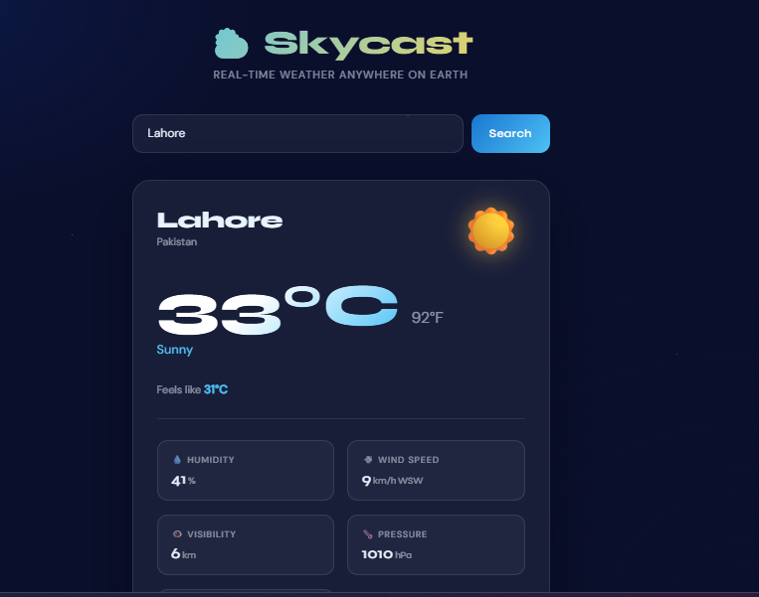
Figure 1: Showing The Lahore Weather.
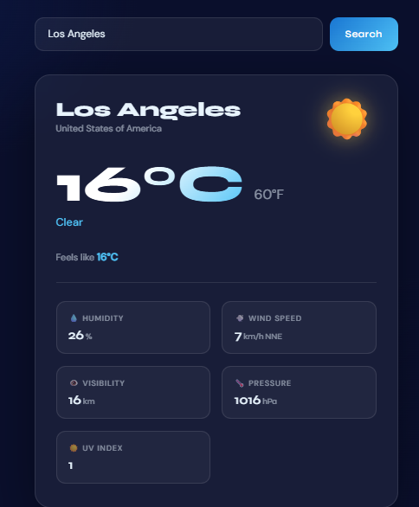
Figure 2: Showing The Los Angeles Weather.

